REPORT ON PUBLIC HEALTH EDUCATION TO IMPROVE NUTRITION FOR SCHOOL FEEDING CATERERS IN THE DISTRICT

INTRODUCTION:
On the 11th May, 2021 the Environmental Health and Sanitation Unit embarked on a Public Health Education by inviting all the School Feeding Caterers in the District aimed at sensitizing them about promotion to improve nutrition in their various schools.
OBJECTIVE:
The main objectives are:
- To classify food items based on their nutrients.
- To state the importance of food nutrients
- To describe a balanced diet and state its importance.
FACILITATORS:
Mr. Diamond Amedewonu (District Environmental Health Analyst)
Mr. Bright Gbedze (Assistant Environmental Health Analyst)
Mr. Isaac Okyere (Senior Environmental Health Assistant)
PARTICIPANTS:
In attendance were Twenty-One (21) Caterers.
DATE: 11TH May, 2021.
TIME: 9:30pm – 11:30am
VENUE: District Assembly Hall, Coaltar.
DISCUSSIONS: Before the commencement of the discussion, the caterers were asked to mentioned any type of food items that they know?
Each and every one mentioned a type of food items, such as banana, cassava, rice, carrot, kontomire, plantain, potatoes, maize, yam, cooking oil, egg, fish, meat, milk, millet, cocoyam, cream, margarine, tomato, okro, cabbage and so on. After this, they were group and assisted to group the food items based on their nutrients. The food items were group under the three types of food. These are;
TYPES OF FOOD | EXAMPLES
ENERGY FOODS | Cassava, rice, yam, maize etc
BODY BUILDING FOODS | Milk, egg, meat, fish etc
MAINTENANCE FOODS | Vitamins, minerals and water etc.

The caterers were made aware that, energy foods are the same as carbohydrates, body building foods are also known as protein foods and vitamins, minerals and water also the same as maintenance foods.
They were also taken through the importance of these various food nutrients. These are depicted on the table below:
FOOD NUTRIENTS | IMPORTANCE
CARBOHYDRATES | 1.They are source of energy to the body.  2. Cellulose in plants cells helps the cell walls to maintain the structure of the cells.
FATS AND OILS | 1.They serve as a source of energy.  2. They dissolve fat soluble vitamins in the body.
PROTEIN | - They are needed for growth and body building.  - They are needed for repair of worn out tissues.
VITAMINS | - They keep skin and eyes healthy.  - They are needed for the formation of strong and teeth.
MINERAL SALTS | - They are needed for the clotting of blood.  - They are needed for the formation of strong bones and teeth.
WATER | - It serves as the medium through which some excretory products are eliminated.  - It transports various substances in the body.

The Caterers were also highlighted on the two classification of vitamins and their examples such as:
FAT SOLUBLE VITAMINS – A, D, E and K
WATER SOLUBLE VITAMINS – B and C.

The charts and table below were used to demonstrate the topic very well for their understanding

FOOD NUTRIENTS

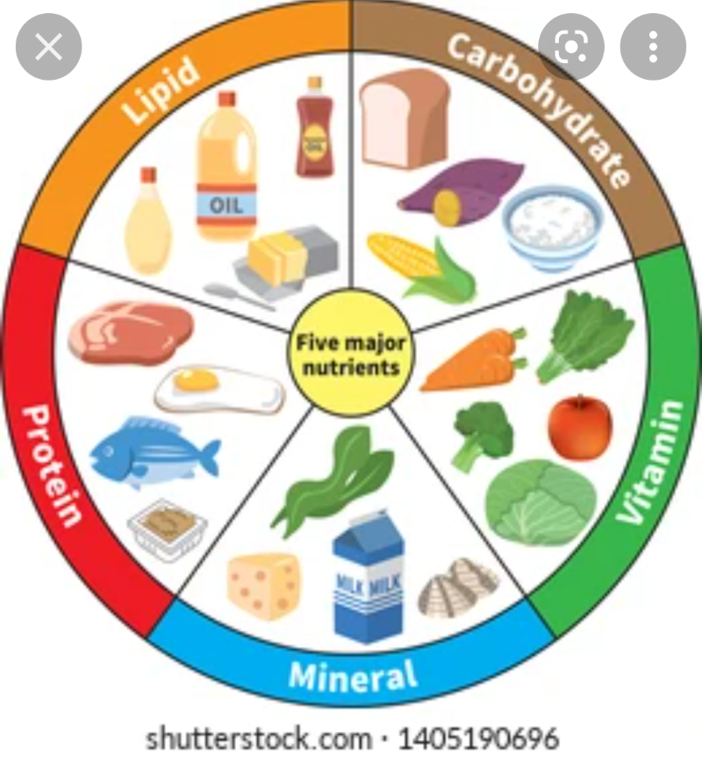

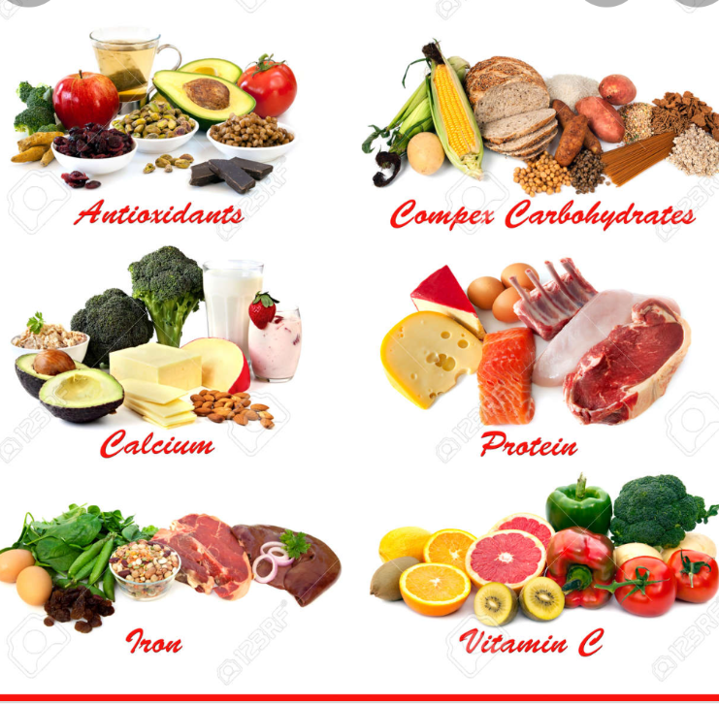

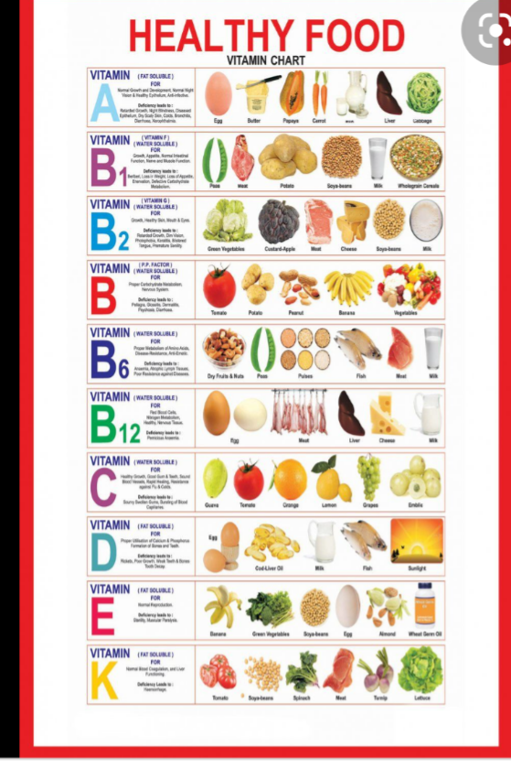
There were a lot of questions from the participants and the questions were well answered to their understanding by the Facilitators.
RECOMMENDATIONS
- There should be more public health education on improving food nutrition District wide.
- School Feeding Caterers should always be given such a public health education on nutrition to enable them prepare a well balance diet for the school children.
- Caterers should use this medium to improve upon their work.

CONCLUSION
The School Feeding Caterers showed some kind of enthusiasms for having undergone these knowledgeable training on food and nutrition. The training was successful and came to halt at exactly 2:30am.

Thanks

……………………….
Diamond Amedewonu

